IF STATEMENTS AND LOGIN VALIDATION EXAMPLES  
**If** statements are required for decision making in programming.

The syntax is as follows;

**If** (CONDITION1 && CONDITION2)

**{**ACTION IF TRUE; **}**

e.g.



**Notation:**

Relation C++

EQUAL ==

NO EQUAL !=

LESS THAN <

GREATER THAN >

LESS THAN OR EQUAL TO <=

GREATER THAN OR EQUAL TO >=

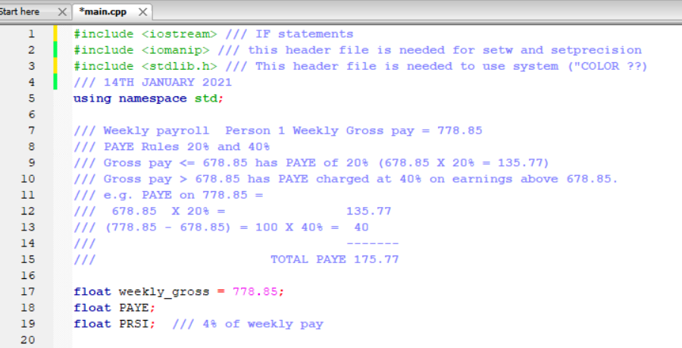

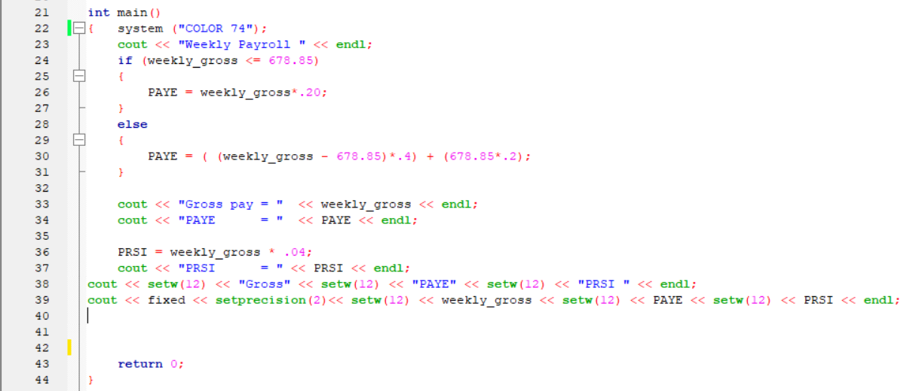

. Login code without **using** a class 071019

